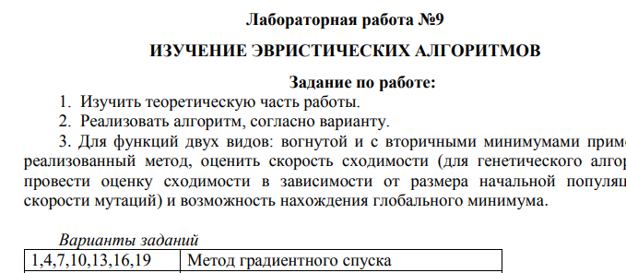

#include <stdio.h>

#include <stdlib.h>

double dfx(double x) {

return 4 * (x * x * x) - 9 * (x * x);

}

double abs_val(double x) {

return x > 0 ? x : -x;

}

double gradient_descent(double dx, double error, double gamma, unsigned int max_iters) {

double c_error = error + 1;

unsigned int iters = 0;

double p_error;

while (error < c_error && iters < max_iters) {

p_error = dx;

dx -= dfx(p_error) * gamma;

c_error = abs_val(p_error - dx);

printf("\nc= %f\n", c_error);

iters++;

}

return dx;

}

int main() {

double dx = 6;

double error = 1e-6;

double gamma = 0.01;

unsigned int max_iters = 10000;

printf("The local minimum is: %f\n", gradient_descent(dx, error, gamma, max_iters));

return 0;

}

